Name: ____________________________________

Grading:
Map: ___/4 pt.
Article/Source: (headline/date/author/URL): ___/4 pts.
Summary: ___/4 pts.
Response/Application: ___/4 pts.
Conventions: ___/4 pts.
Total: ___/20 pts.
Date: ________________ Class: _______________

WEEKLY CURRENT EVENT

Date of Article:
Headline:
Author:
Source (URL) or article attached

Where did event(s) occur? Color in or place an “x” on the map.
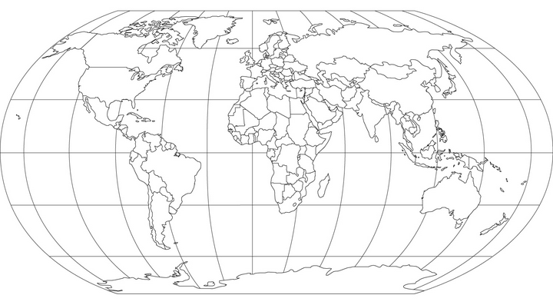

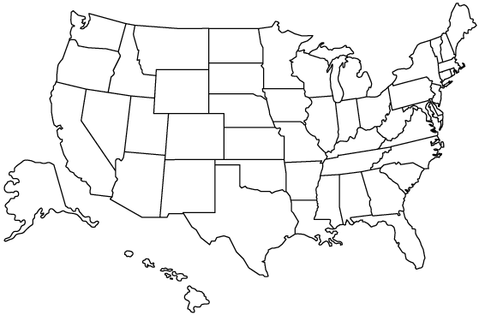

Summary:
(Paragraph form: Who, What, Where, When, Why)

___________________________________________________________________________________
___________________________________________________________________________________
___________________________________________________________________________________
___________________________________________________________________________________
___________________________________________________________________________________
___________________________________________________________________________________
___________________________________________________________________________________
___________________________________________________________________________________
___________________________________________________________________________________
___________________________________________________________________________________

Response:
(Paragraph form)
- What is your reaction to the events? How does it make you feel?
- What is your opinion of the events that happened and why do you feel this way?
- How does/can this relate to you, your life, your community
- What impact will/could this have on your, your life, your community, the world
___________________________________________________________________________________
___________________________________________________________________________________
___________________________________________________________________________________
___________________________________________________________________________________
___________________________________________________________________________________
___________________________________________________________________________________

Name: ____________________________________

Grading:
Map: ___/4 pt.
Article/Source: (headline/date/author/URL): ___/4 pts.
Summary: ___/4 pts.
Response/Application: ___/4 pts.
Conventions: ___/4 pts.
Total: ___/20 pts.
Date: ________________ Class: _______________

WEEKLY CURRENT EVENT

Date of Article:
Headline:
Author:
Source (URL) or article attached

Where did event(s) occur? Color in or place an “x” on the map.

Summary:
(Paragraph form: Who, What, Where, When, Why)

___________________________________________________________________________________
___________________________________________________________________________________
___________________________________________________________________________________
___________________________________________________________________________________
___________________________________________________________________________________
___________________________________________________________________________________
___________________________________________________________________________________
___________________________________________________________________________________
___________________________________________________________________________________
___________________________________________________________________________________

Response:
(Paragraph form)
- What is your reaction to the events? How does it make you feel?
- What is your opinion of the events that happened and why do you feel this way?
- How does/can this relate to you, your life, your community
- What impact will/could this have on your, your life, your community, the world
___________________________________________________________________________________
___________________________________________________________________________________
___________________________________________________________________________________
___________________________________________________________________________________
___________________________________________________________________________________
___________________________________________________________________________________

